THE AMERICAN BOARD OF ANESTHESIOLOGY (ABA) IN-TRAINING EXAMINATION
INSTRUCTIONS FOR EXAMINEES

Name: ______________________________________ Examinee ID Number: _________________

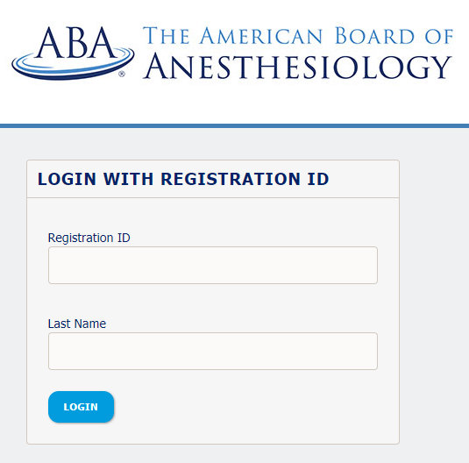
You will be taking the ABA’s In-Training Examination (ITE) today. The Login screen shown below should be open on your workstation. If it is not, please notify your proctor.

- When instructed to do so by your proctor:
  - Enter your Registration ID in the first box. Your Registration ID is: 2026_######## where “########” is replaced by your Examinee/ABA ID number with no dash. If you do not know your ABA ID number, it is included on your Seat Assignment Form.
    - If your ABA ID number is 12345678 and you are taking the ITE-Anesthesiology exam, your Registration ID will be 2026_12345678.
    - If you are taking an ITE-subspecialty exam, your registration ID will include the subspecialty code after the exam year, as demonstrated below:
      - ITE-Critical Care Medicine: 2026_CCM_12345678
      - ITE-Pediatric Anesthesiology: 2026_PA_12345678
      - ITE-Pain Medicine: 2026_PM_12345678
  - Enter your Last Name exactly as it appears on your Seat Assignment Form in the second box and click the Login button. This will take you to a Welcome screen.
- The Welcome screen will display a Start Test link, which you will click to launch your exam (this does not start your exam time).
- The next screen is a title screen that displays a welcome message. You will advance to the next page by clicking the Next button in the lower right-hand corner of the screen.
- The ABA’s Rules of Conduct page will be displayed. You must read and select AGREE to acknowledge that you are the examinee and that you accept and agree to be bound by the terms and conditions of this agreement. To advance to the next page, you must click on the Agree button in the lower right-hand corner of the screen.
- You will be taken to a Key Features page which provides you with information about the navigation buttons and other supported functionalities in the exam.
- Once you have reviewed the items on the Key Features page, you will see the Next button at the bottom of the screen. Once you click Next, your first exam question will appear and your time will begin. Once your exam begins, a test timer will appear at the top right of the screen to help you monitor your time.
- On the Review page you will see all items in the exam, but you can also choose to only view incomplete items by clicking on the REVIEW INCOMPLETE button or marked items by clicking on the REVIEW MARKED button in the lower left-hand corner of the Review page. To navigate to any item, you will point-and-click the item number. Alternately, there is a Go to Question box in the lower right-hand corner of the Review page. You may also place your cursor in that box, type in the number of the item you wish to go to and click Enter.
- Please write your Examinee ID in the upper right-hand corner of this page. You may use the back side of this page as scratch paper during the exam.

